|  |
| --- |
| Expenses tracker |
| **Python Final Project – Spring Semester 2022/2023** |

|  |
| --- |
| **2023 | By: Ines Mtioui** |

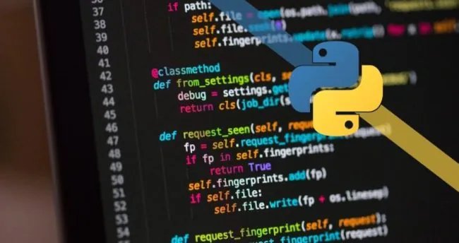

# Executive Summary

## Summary of your final project goes here. Written after the project is completed

The Executive Summary is used to summarize all the work you researched, coded, and wrote for this final project assignment.

The Python Expenses Tracker project is a program designed to help individuals track their expenses. The program allows users to add their expenses, categorize them, add the amount spent, and provide total spending.

The project has the following features:

1. Add expenses: users can add expenses by providing the following details: Date, Description, Category, and amount.
2. Expenses List: this feature allows users to list and view all added expenses, by displaying each with an ID number.
3. Delete expenses: users can delete expenses using the ID number from the expenses list. This function has been designed to correct the ID numbers of the list.
4. Total Expenses Calculation: This function displays the total amount of the expenses by summing up the amounts of all listed records.
5. Get expenses to retrieve all expenses from the database.
6. All expense data are stored and saved in a SQL database.

The Expenses Tracker program provides a simple and efficient solution for users to track their expenses and spending habits. It also helps them maintain better control over their finances. This project can be enhanced by adding additional features such as adding a Gui interface, generating expense reports by month or year, and adding functions to limit the monthly budget.

# Part 1: Final Project Planning

## What you set out to do. What you hope to accomplish.

The goal of the Python Expenses Tracker project is to create a program that allows users to track their expenses and manage their finances effectively.

Additionally, the project aimed to showcase the use of Python programming and database management to solve real-world problems. This is the beginning of the project. However, I am planning to continue working on it and develop a reliable and user-friendly application to help users manage their finances.

# Part 2: Python Elements Used

## What data and methods were necessary for your project? Give specific examples and the related code? (For example: *Lists* and the related code)

Several functions and methods have been used in the Python Expenses Tracker project. Here are some examples of the project methods:

1. Add_expenses:  
     
   A picture containing text, screenshot, font

   Description automatically generated
2. Show_expenses:  
     
   A screen shot of a computer program

   Description automatically generated with low confidence
3. Calculate_total_expenses:  
     
   A picture containing text, screenshot, font

   Description automatically generated
4. Delete_expense:  
     
   A screen shot of a computer program

   Description automatically generated with low confidence
5. Create a database:  
     
   A screenshot of a computer program

   Description automatically generated with medium confidence

# Part 3: The Process

## Describe how you completed the final project. What techniques did you use (be specific)? How did you decide what would work best? What issues did you have?

To complete the project, I created a simple plan that has several techniques:

1. I’ve done some research for the project.
2. Checked the project requirements and I tried to add as much as possible from the concepts that have been covered during the semester.
3. Design the database to store the data. Created a table with the appropriate columns (date, description, category, amount)
4. I used the sqlite3 module to establish a connection between Python and SQL databases.
5. I wrote the necessary code to ensure the functionality of the application:

* Adding expenses
* Listing expenses
* Deleting expenses
* Calculating the total expenses
* And the exit

1. Testing and debugging the code. Debugging helped me a lot to fix a lot of errors and issues in the code.

Overall, the final project involved a combination of planning, designing, coding, testing, and fixing errors.

# Part 4: Results

## Your screenshots, code, and documentation go here.

1. Here is a screenshot of the database created:  
     
   A screenshot of a computer

   Description automatically generated
2. add item:  
     
   A screenshot of a computer program

   Description automatically generated with medium confidence
3. List expenses:  
     
   A screenshot of a computer

   Description automatically generated with medium confidence
4. Calculate Total Expenses:  
     
     
   A screenshot of a computer

   Description automatically generated
5. Delete Expense:  
     
   A screenshot of a computer

   Description automatically generated

# Part 5:

Citations – Cite any outside resources employed.  
  
1- Youtube: <https://www.youtube.com/watch?v=tMLsR0_2yIE>

2- Article by [randerson112358](https://randerson112358.medium.com/?source=post_page-----234f5b5e138b--------------------------------), published   
Jun 3, 2022, link:  
https://randerson112358.medium.com/build-an-expense-tracker-using-python-234f5b5e138b

3- copied some code from previous assignments